#### 

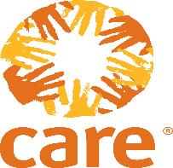

**Request for Quotations#( 11998)**

**Invitation for : Quotations for** Drugs and Medical Equipment

**Care International in sudan (CIS), one of the world’s leading international humanitarian agencies working in Sudan, currently implements significant projects in South & East Darfur , South Kordofan. And East Sudan**

CARE International in Sudan, is seeking for qualified companies & Suppliers and or individuals to provide their best Offers with cost for transportation

⇒  Drugs and Medical Equipment for CARE international in Sudan – East Darfor Aldain Office according to the attached LIST

The interested applicants Can find the tender documents from

* Care International in Sudan Reception, Sudan, Office located at Nile Tower, 2th Floor, Building 20, Block 10, Mamoun Behairy Street, Near AFRA Mall, Khartoum, Sudan.
* The Sudan Bids and Tenders Platform

Closing date 5th October 2021. The Bids will be receiving during working hours between 8:30 am – 3:00 pm. All Bids will be submitting in sealed envelopes, and clearly marked with (**CARE, SDN/11998/FY21,** and make sure is dropped in the tender box, the last day of Bids submission is 5th October 2021 at 2:00pm Sudan local Time. CARE will not receive any bids after the Closing date and also the unsealed bids wouldn't be considered for bidding.

Addressed to: CIS reception drop in the tender box, or Email to Mohammed.AlaEldin@care.org 0993333378